# The Foundation Assessment (Phase One,Round One) Exam Paper A

## Exam Duration:180 minutes

**Personal Information**  
Name: _________________  
Department: _________________  
Employee Number: _________________

Job Grade: _________________

### I. Multiple Choice Questions (each question 2 points, total 30 points)

**Instructions for Answering:** Please select one or more appropriate answers from the options for each question and fill in the answers in the corresponding places on the answer sheet or test paper.

1. If the width of an image is 800 pixels, and the height is 600 pixels, the total number of pixels is (C)

A. 1400

B. 2800

C. 480000

D. Cannot be determined

1. Main application categories of machine vision (ABCD)
2. Positioning and alignment
3. Recognition and reading
4. Dimension measurement
5. Defect inspection
6. Camera triggering methods do not include (D)

A Software trigger

B Hardware rising edge trigger

C Hardware falling edge trigger

D Free running mode

1. During the exposure time, the distance moved by the object being measured at least how many pixels will result in ghosting (A)

A 1 pixel

B 2 pixels

C 3 pixels

D none of the above

1. The histogram in Blob is a statistical count of the number of pixels (A) in an image
2. According to different grayscale values
3. According to different contrasts
4. According to different brightness levels
5. All of the above
6. Among the following options, those describing the function of machine vision guidance are (ABCD)

A. Precise gripping and placement of parts by grippers

B. Providing product coordinates

C. Accurate dimensions

D. Assembly quality inspection

1. To address image distortion, the following measures can be adopted (ACD)
2. Use low-distortion lenses
3. For the same field of view, choose lenses with shorter focal lengths
4. Calibration
5. Image distortion correction
6. What are the components of a vision system (ABCD)
7. Light source and light controller
8. Camera and lens
9. Industrial computer
10. Vision software
11. In case of blurry imaging, what actions can be taken to make the image clearer (AB)
12. Adjust the working distance of the camera
13. Adjust the focal length of the lens
14. Replace with a higher resolution camera
15. Adjust the image in the software
16. Which of the following images has the best effect (D)

A. B.

C. D.

1. What is the abbreviation for frame rate in English? (C)
2. CCD
3. COMMS
4. FPS
5. FPV
6. What are the active cooling methods for a light source? (ABC)
7. Air cooling (fan)
8. Gas cooling
9. Water cooling
10. Natural cooling
11. The larger the aperture coefficient F-value, the amount of light transmission (B)
12. Increases
13. Decreases
14. Remains the same
15. None of the above are correct
16. Image after binarization (B)

A. Must be a black and white image

B. Only two gray levels

C. Can be used directly for image recognition

D. Retains all the original image information

1. The main purpose of image binarization is (B)

A. Increase image color

B. Simplify image information, highlight the target

C. Improve image resolution

D. Remove image noise

### II. Fill in the blanks (each blank 1point, total20points)

**Answer instructions**: Please fill in the correct answer in the blank space.

1. Common data interfaces of cameras include Gigabit network ,USB ,IEEE1394 ,CameraLink .
2. What are the two types of connections to the computer host for the light source controller? Network port ,Serial port.
3. The four ports labeled CH on the light source controller are connected to light sources.
4. Area scan cameras have two exposure methods, global and rolling shutter. Cameras with rolling shutter are only suitable for shooting stationary objects.
5. What are the classifications of cameras according to output mode, target type, image color, and chip technology?

Classified by output mode: Analog cameras and digital cameras

Classified by image color: Color cameras and black and white cameras

Classified by chip technology: CCD cameras and CMOS cameras

Classified by target type: Area array cameras and line scan cameras

1. In the basic image information, Resolution represents the number of pixels in the horizontal and vertical directions.
2. The execution order of all operators added within each standard operator block is from top to bottom executed sequentially.
3. The greater the pixel depth, the number of grayscale levels increases
4. In digital image grayscale levels, 255 represents pure white
5. Known camera resolution 4000pixel*3000pixel field of view 50mm*37.5mm then the pixel precision is 0.0125mm/pixel
6. Image binarization simplifies the pixel values of an image to two states.

### Three Practical Operation Questions (total50points)

Dimension Measurement Assessment (see attachment)

**Communication Mode:**TCP/IP Communication

**Send Command Description:** Branch One(Calibration)Trigger command: Calib; Branch Two(Detection)Trigger command: T1;

**Data Return Description:** Branch One returns data: Calib, OK (NG),Branch Two Return Data: T1, length: xxx, width: xxx

**General Requirements:** Communication control, Branch One calibrates the calibration plate, Branch Two measures the screen,

**Process**: Requires adding two branches and entering different process branches according to different commands, each time a command is received, one picture is processed; if no command is received, the communication is in a waiting for command state;(Total 6 commands, 6 pictures)

**Branch:** Branch One: Calibrate the calibration plate, generate a calibration file, and name it with the date (month day) plus the initials of the name;

Branch Two: Perform screen measurement, save the result image, and name it with the date (month day) plus the original image name

**Function Requirements:**

Screen Measurement

1. Calculate the length and width of the screen, and return the actual measured distance (not pixels) to the communication

(Format: T1, length: xxx, width: xxx)

2. Save the window image (the image source is the display capture);

(Image save path: "D:/Export Images/Initials of Name/Screen Measurement/Window Image", image naming: "Measurement Window Image"+ current time)

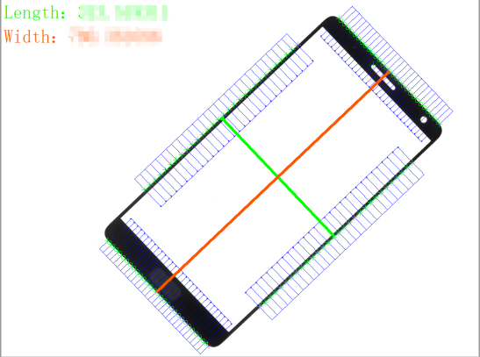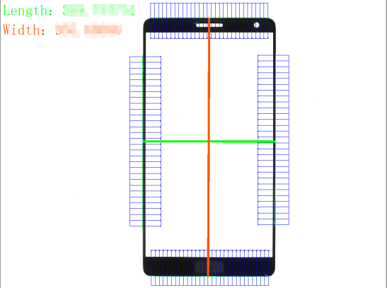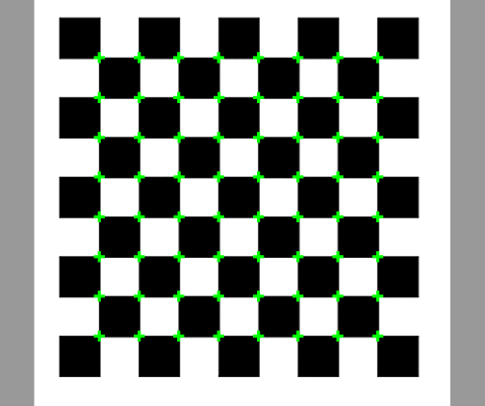Screen Measurement Effect Diagram Calibration Plate Calibration